**Homework 2**

**Instructions:** Do as many of the problems as you like, but make sure to complete at least **three**. Then the whole class will create a solution jointly (write below, or create a separate file; either is OK). One problem can have multiple solutions, so if your solution is different than the one already posted and you’d like to share yours with others, feel free to add yours. Make sure to separate different solutions to minimize confusion.

1. Show that if *a* and *b* divide *M* and [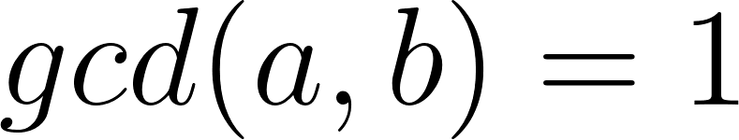](https://www.codecogs.com/eqnedit.php?latex=gcd(a%2Cb)%3D1#0), then [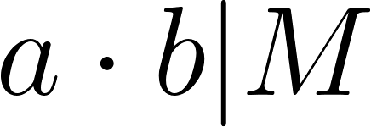](https://www.codecogs.com/eqnedit.php?latex=a%5Ccdot%20b%20%7C%20M#0).

* We were told that $gcd(a, b)⋅lcm(a, b)=a⋅b$
* Thus if $gcd(a, b)=1$ then $lcm(a,b)=a⋅b$
* We were also told that the least common multiple of 2 numbers must divide every common multiple of those numbers.
* Therefore, since $M$ is a common multiple of $a$ and $b$, then their least common multiple, $a⋅b$, divides $M$.

1. a. Prove that [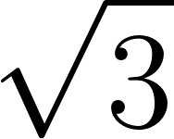](https://www.codecogs.com/eqnedit.php?latex=%5Csqrt%7B3%7D#0) is irrational.

* Proof by contradiction.
* Assume $\sqrt{3 }= a/b$ where $gcd(a,b)=1$ (so the fraction is in simplest form)
* $3 = a^{2}/b^{2}$, $3b^{2} = a^{2}$
 $3|a^{2} →3|a$

 + Proof by contradiction
  + Assume $3 !| a$, then $a=3k+1$ or $a=3k+2$
  + Thus, $a^{2}=3(3k^{2}+2k)+1$ or $a^{2}=3(3k^{2}+4k+1)+1$
  + So if 3 does not divide $a$ then 3 does not divide $a^{2}$ and we've reached a contradiction
* Thus $a=3j$ for some $j$
* $3b^{2}=a^{2}$ so $3b^{2}=(3j)^{2}=9j^{2}$ thus $b^{2}=3j^{2}$
* Using the previous proof, $3|b^{2}→3|b$
* $3|a$ and $3|b$ contradicting our assumption that $gcd(a, b)=1$

b. You likely also saw that [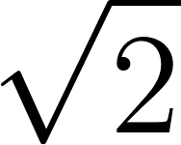](https://www.codecogs.com/eqnedit.php?latex=%5Csqrt%7B2%7D#0) is irrational in MTH 210. So, it feels like we can make a general statement. Come up with at least two different generalizations of the statement “[](https://www.codecogs.com/eqnedit.php?latex=%5Csqrt%7B2%7D#0) is irrational.” No need to write full proofs, but give some good reasonings for why the generalizations would be true.

* $\sqrt{p}$ is irrational for all prime $p$
  + The mini proof by contradiction within the previous proof, which was a large part of the overall proof, could be removed in favor of Euclid's Lemma. Which could have been used above as well.
* $\sqrt[k]{2}$ is irrational for all $k$ where $|k|>1$
  + The mini proof by contradiction within the previous proof could be replaced by a proof by induction.

1. Show that [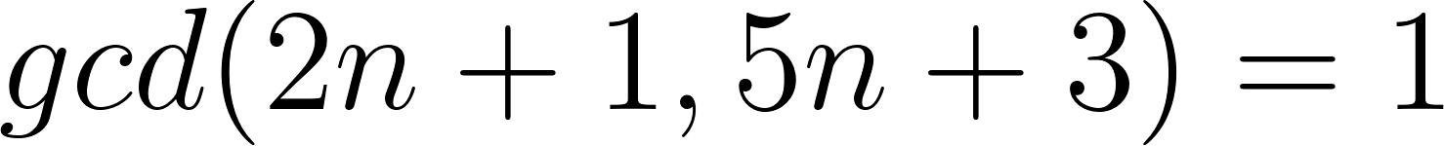](https://www.codecogs.com/eqnedit.php?latex=gcd(2n%2B1%2C5n%2B3)%3D1#0) for every *n*.

1. Show that if [](https://www.codecogs.com/eqnedit.php?latex=gcd(a%2Cb)%3D1#0), then [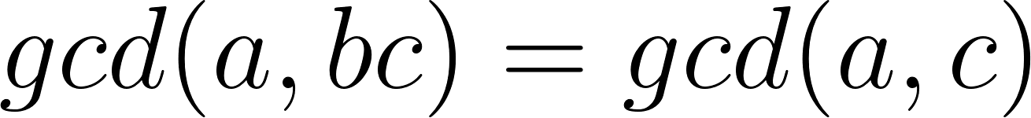](https://www.codecogs.com/eqnedit.php?latex=gcd(a%2Cbc)%3Dgcd(a%2Cc)#0).

* Since , and $b$ share no factors. Thus, multiplying $bc$ has no more factors in common with $a$ than just $c$. Thus, $gcd(a,bc)=gcd(a,c)$.

1. Prove that if *M* is a multiple of *a* and *b*, then [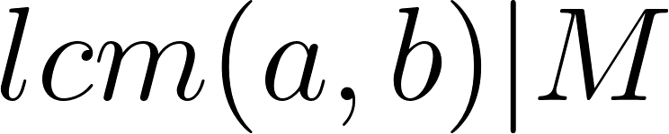](https://www.codecogs.com/eqnedit.php?latex=lcm(a%2Cb)%7CM#0). (Hint: One way to do this uses Division algorithm and contradiction. Another way uses the relationship between lcm and gcd, and Euclid’s lemma. There are possibly other ways too.)
2. (For those who have completed MTH 350) Look up the definitions of a prime element in a commutative ring, and an irreducible element in an integral domain. Since these words are different, the terms should not imply each other. Figure out in which cases one implies the other. Briefly summarize.
3. Write a code to find lcm of any two given positive integers. Then use lcm to find the gcd of the two integers.

* def lcm(a, b):
  + if a<0 or b<0:
    - return lcm(abs(a), abs(b))
  + if a == 0 or b == 0:
    - return 0
  + else:
    - larger = max(a, b)
    - multiple = larger
    - while not (m % a == 0 and m % b == 0):
      * multiple += larger
    - return multiple
* def gcd(a, b):
  + return a*b/lcm(a,b)